

**Semester VI (CS, SE) Section (A) (Spring 2022) Course Instructor(s): Riaz Ali Soomro**

**CSC-325: Web Engineering - Lab**

**Lab 01: Introduction to HTML**

# Objective(s):

1. To create HTML pages with CSS
2. To implement different levels of stylesheet

**Lab Task(s):**

**Exercises**

**TASK 1 Create the following payment form using HTML and CSS. Note: This is just a sample: Each student should apply different/unique styles**

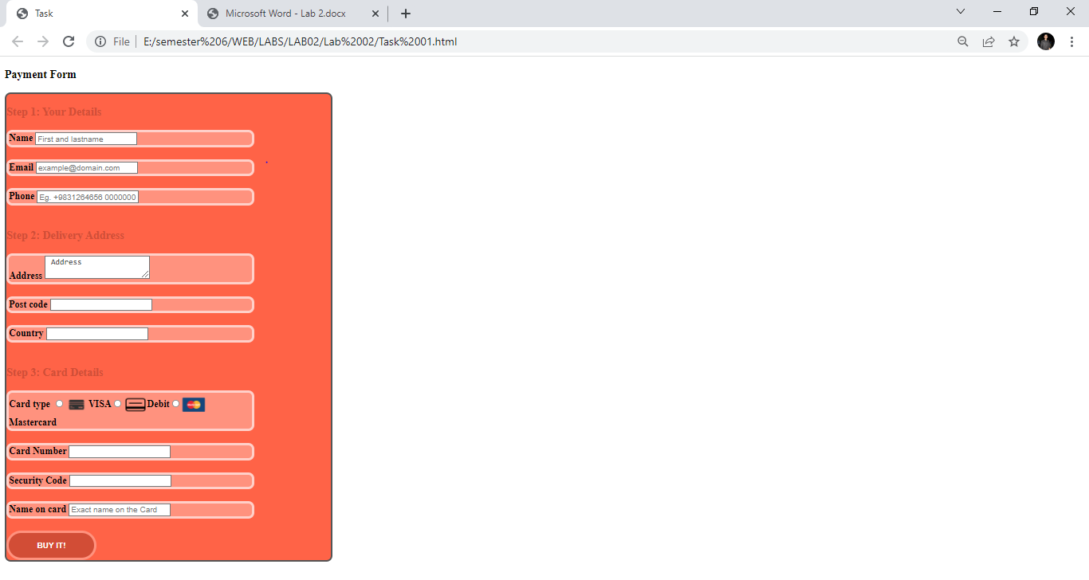

**HTML CODE**

<!DOCTYPE html>

<html>

<head>

<title>Task</title>

<link rel="stylesheet" type="text/css" href="style.css">

</head>

<body>

<h3>Payment Form</h3>

<section class="form" hight="100px">

<h3 class="steps" align="left"> Step 1: Your Details</h3>

<div class = "grove"><label><b>Name</label>

<input type="Text" name="name" placeholder="First and lastname "></div><br>

<div class = "grove"><label>Email</label>

<input type="Text" name="email" placeholder="example@domain.com"></div><br>

<div class = "grove"><label>Phone</label>

<input type="Text" name="phone" placeholder="Eg. +9831264656 0000000"></div>

<br>

<h3 class="steps"> Step 2: Delivery Address</h3>

<div class = "grove"><label>Address</label>

<textarea> Address</textarea></div><br>

<div class = "grove">

<label>Post code</label>

<input type="Text" name="Postcode" placeholder=""></div>

<br>

<div class = "grove"><label>Country</label>

<input type="Text" name="Country" placeholder="">

</div><br>

<h3 class="steps"> Step 3: Card Details</h3>

<div class = "grove"><label>Card type</label>

<input type="radio" name=""><img src="VISA.png" width="40px" height="40px" align="center"><label>VISA</label><input type="radio" name=""><img src="debit.png" align="center" width="40px" height="40px"><label>Debit</label><input type="radio" name=""><label><img src="Mastercard.png" width="40px" height="40px" align="center">Mastercard</label>

</div>

<br><div class = "grove">

<label>Card Number</label>

<input type="number" name="no" placeholder=""></div><br>

<div class = "grove"><label>Security Code</label>

<input type="number" name="no" placeholder=""></div><br>

<div class = "grove"><label>Name on card</label>

<input type="number" name="no" placeholder="Exact name on the Card">

</div>

<br>

<button class="btn"><b>BUY IT!</b></button>

</section>

</body>

</html>

**CSS CODE**

.form{

background-color: #ff6347;

size: 30px;

border-style: solid;

border: 3px solid #555;

height: 60%;

width: 30%;

border-style: solid;

border-radius: 10px;

}

.steps{

color: #d24d36;

text-align: left;

}

.grove{

border-style: solid;

border-color: #ffd0c9;

background-color: #ff927e;

width: 75%;

height: 50%;

align-content: left;

border-radius: 10px;

}

.btn{

color: white;

background-color: #d24d36;

border: solid;

border-color: #ff927e;

shape-outside: margin-box;

width: 150px;

height: 50px;

border-radius: 30px;

}

**TASK 2Design given below layout of a page using HTML5 elements and apply required CSS.**

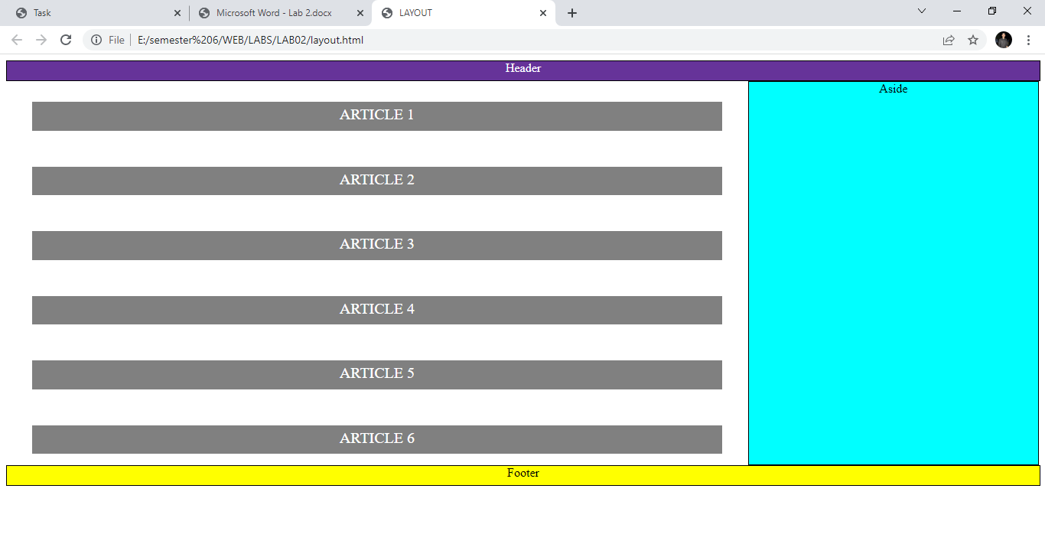

**HTML CODE**

<html>

<head>

<link rel="stylesheet" href="style.css">

<title>LAYOUT</title>

</head>

<body>

<div class ="div1">Header</div>

<section>

<article id = "a1"> ARTICLE 1 </article><br>

<article id = "a2"> ARTICLE 2 </article><br>

<article id = "a3"> ARTICLE 3 </article><br>

<article id = "a4"> ARTICLE 4 </article><br>

<article id = "a5"> ARTICLE 5 </article><br>

<article id = "a6"> ARTICLE 6 </article>

</section>

<div class ="div2">Aside</div>

<div class="div3">Footer</div>

</body>

</html>

**CSS CODE**

.div1 {

width: 100%;

height: 25px;

background-color: rebeccapurple;

border: 1px solid black;

clear: both;

color:white;

text-align:center;

}

.div2 {

width: 28%;

height: 500px;

background-color:aqua;

border: 1px solid black;

float: right;

text-align:center;

}

.div3 {

width: 100%;

height: 25px;

background-color: yellow;

border: 1px solid black;

clear: both;

text-align:center;

}

section {

width: 66%;

height: 76%;

font-size: 40px;

text-align: center;

color: white;

position: absolute;

margin-left: 2.5%;

margin-top: 2%;

}

#a1 {

background-color: gray ;

width: 100%;

height: 6.5%;

color: white;

font-size: 20px;

padding-top:5px;

}

#a2 {

background-color: gray ;

width: 100%;

height: 6.5%;

color: white;

font-size: 20px;

padding-top:5px;

}

#a3 {

background-color: gray ;

width: 100%;

height: 6.5%;

color: white;

font-size: 20px;

padding-top:5px;

}

#a4 {

background-color: gray ;

width: 100%;

height: 6.5%;

color: white;

font-size: 20px;

padding-top:5px;

}

#a5 {

background-color: gray ;

width: 100%;

height: 6.5%;

color: white;

font-size: 20px;

padding-top:5px;

}

#a6 {

background-color: gray ;

width: 100%;

height: 6.5%;

color: white;

font-size: 20px;

padding-top:5px;

}

**TASK 3 Create a below given page using HTML & CSS.**

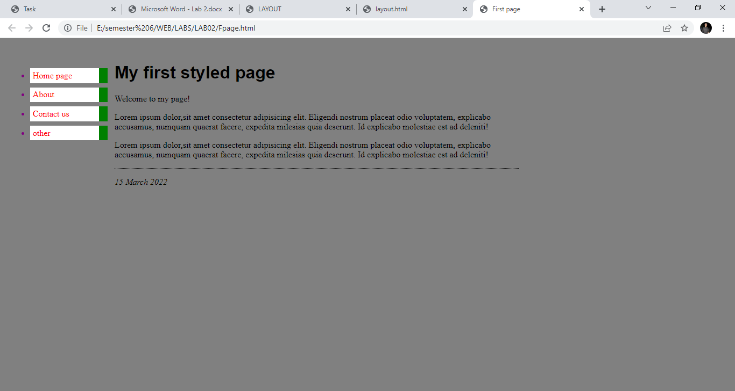

**HTML CODE**

<html>

<head>

<title>First page</title>

<style type="text/css">

body {

color: purple;

background-color: gray }

</style>

<link rel ="stylesheet" href="fpage.css" >

</head>

<body>

<ul class ="side">

<li><a href="homepage.html">Home page</a></li>

<li><a href="about.html">About</a></li>

<li><a href="contact.html">Contact us</a></li>

<li><a href="other.html">other</a></li>

</ul>

<div class="div1">

<h1>My first styled page</h1>

<p>Welcome to my page!</p>

<p>Lorem ipsum dolor,sit amet consectetur adipisicing elit. Eligendi nostrum placeat odio voluptatem, explicabo accusamus, numquam quaerat facere, expedita milesias quia deserunt. Id explicabo molestiae est ad deleniti!</p>

<p>Lorem ipsum dolor,sit amet consectetur adipisicing elit. Eligendi nostrum placeat odio voluptatem, explicabo accusamus, numquam quaerat facere, expedita milesias quia deserunt. Id explicabo molestiae est ad deleniti!</p>

<!-- Sign and date the page, it's only polite! -->

<address>15 March 2022

</address>

</div>

</body>

</html>

**CSS CODE**

ul.side {

position: absolute;

top: 2em;

left: 1em;

width: 9em

}

h1 {

text-align:left;

color:black;

font-family: Helvetica, Geneva, Arial,

SunSans-Regular, sans-serif

}

p{

text-align:left;

color:black;

}

ul.side li {

background: white;

margin: 0.5em 0;

padding: 0.3em;

border-right: 1em solid green }

ul.side a {

text-decoration: none }

a:link {

color:red; }

a:visited {

color:black; }

address {

color:black;

text-align:left;

margin-top: 1em;

padding-top: 1em;

border-top: thin dotted }

.div1 {

width: 55%;

height: 500px;

position: absolute;

margin-left: 15%;

margin-top: 1.2%;

float: right;

text-align:center;}

**TASK 4 Create the following quiz design in HTML & CSS. Note: Use the FontAwesome website for getting the icons used in this task.**

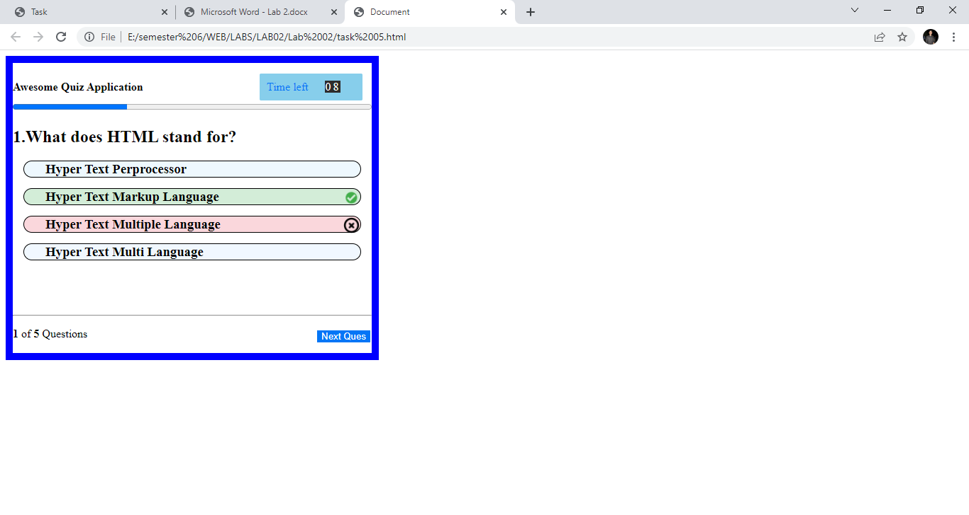

**HTML CODE**

<!DOCTYPE html>

<html lang="en">

<head>

<meta charset="UTF-8">

<meta http-equiv="X-UA-Compatible" content="IE=edge">

<meta name="viewport" content="width=s, initial-scale=1.0">

<title>Document</title>

<link rel="stylesheet" href="./5.css">

</head>

<body class="border">

<span>

<b>Awesome Quiz Application</b>

</span>

<span class="time"> Time left <span class="num">08</span></span>

<progress class="file" value="32" max="100"> 32% </progress>

<div>

<h2>1.What does HTML stand for?</h2>

</div>

<div>

<h3 class="s1">Hyper Text Perprocessor</h3>

<h3 class="s2">Hyper Text Markup Language <img src="./correct.png"></h3>

<h3 class="s3">Hyper Text Multiple Language<img class="img2" src="./wrong.png"></h3>

<h3 class="s4">Hyper Text Multi Language</h3>

</div>

<br>

<br>

<br>

<hr>

<div>

<p><b>1</b> of <b>5</b> Questions

<button class="button">Next Ques</button>

</p>

</div>

</body>

</html>

**CSS CODE**

.border {

border-color: blue;

border-style: solid;

border: 10px solid blue;

width: 506px;

height: 410px;

display: inline-block;

/* box-sizing: border-box;*/

}

.time {

display: inline-block;

margin-left: 160px;

background-color: skyblue;

color: rgb(4, 118, 246);

width: 125px;

margin-top: 15px;

padding: 7px 7px;

border-style: double;

border-color: skyblue;

text-align: center;

border-radius: 2px;

}

.num {

background-color: rgb(46, 44, 44);

color: white;

margin: 20px;

letter-spacing: 3px;

border-style: square;

}

.file {

width: 100%;

}

.s1 {

border: 1px;

border-style: solid;

border-spacing: 10px;

background-color: rgb(238, 248, 254);

margin: 15px;

border-radius: 15px;

padding-left: 30px;

}

.s2 {

border: 1px;

border-style: solid;

background-color: rgb(211, 237, 216);

margin: 15px;

border-radius: 15px;

padding-left: 30px;

}

.s3 {

border: 1px;

border-style: solid;

background-color: rgb(250, 215, 220);

margin: 15px;

border-radius: 15px;

padding-left: 30px;

}

.s4 {

border: 1px;

border-style: solid;

background-color: rgb(241, 248, 255);

margin: 15px;

border-radius: 15px;

padding-left: 30px;

}

img {

float: right;

height: 25px;

width: 25px;

}

.button {

background-color: rgb(4, 118, 246);

float: right;

border: none;

color: white;

text-align: center;

display: inline-block;

margin: 4px 2px;

cursor: pointer;

}

**TASK 6 Create the following design using HTML and CSS. Note: You can use any value for the size of the two texts but the first one should be a bit larger than the second one (for example, the size of text “Call to action! …” could be about 25px and the text below it could be 18px). The text of the button is bold as well.**

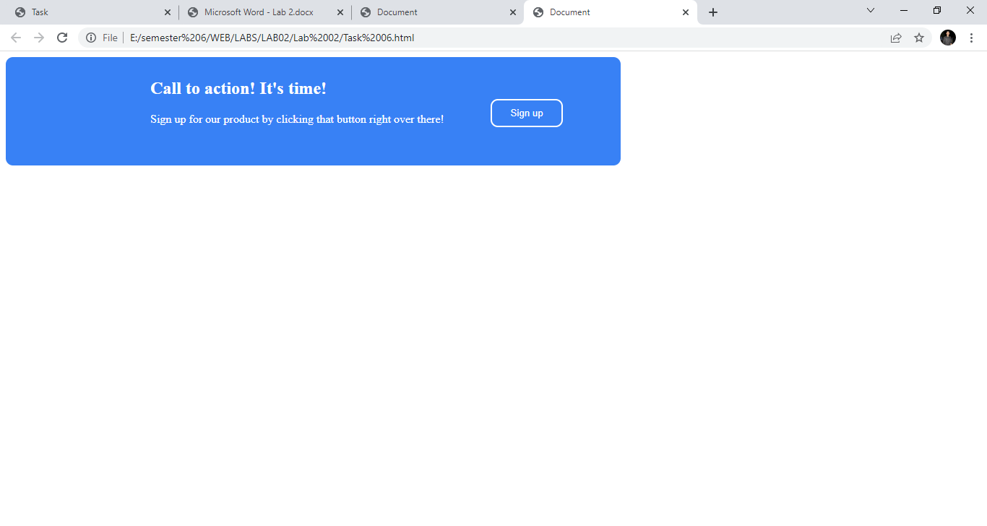

**HTML CODE**

<!DOCTYPE html>

<html lang="en">

<head>

<meta charset="UTF-8">

<meta http-equiv="X-UA-Compatible" content="IE=edge">

<meta name="viewport" content="width=device-width, initial-scale=1.0">

<title>Document</title>

<link rel="stylesheet" href="6.css">

</head>

<body>

<div class="block">

<h2>Call to action! It's time!</h2>

<pr class="text">Sign up for our product by clicking that button right over there!</pr>

<div class="btn">

<button>Sign up</button>

</div>

</div>

</body>

</html>

**CSS CODE**

.block {

height: 150px;

width: 851px;

background-color: rgb(56, 129, 245);

border-radius: 10px;

color: white;

display: inline-block;

}

h2 {

margin-top: 30px;

margin-left: 200px;

font-weight: 50px;

}

.text {

margin-top: 30px;

margin-left: 200px;

font-weight: 25px;

}

button {

color: white;

border-radius: 10px;

border-style: solid;

border-color: white;

background-color: rgb(56, 129, 245);

display: inline-block;

padding: 10px 25px 10px 25px;

margin-bottom: 500px;

float: right;

position: absolute;

top: 10%;

right: 43%;

}

**TASK 7 Create the following design using HTML and CSS. Note: You can use any values of your choice for sizes of texts or the (inner) containers but the overall look should be similar.**

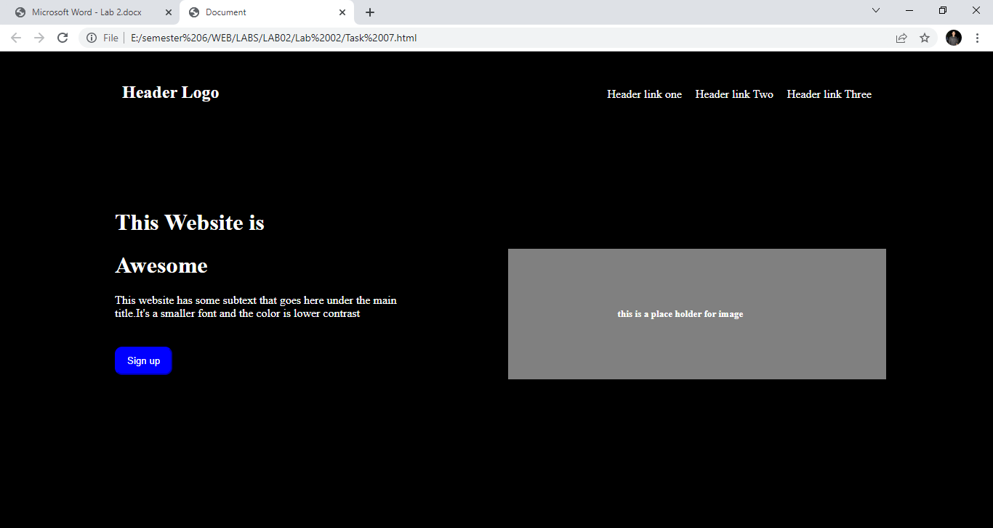

**HTML CODE**

<!DOCTYPE html>

<html lang="en">

<head>

<meta charset="UTF-8">

<meta http-equiv="X-UA-Compatible" content="IE=edge">

<meta name="viewport" content="width=device-width, initial-scale=1.0">

<title>Document</title>

<link rel="stylesheet" href="./7.css">

</head>

<body>

<nav>

<ul class="nav">

<li class="navlogo">

<h1>Header Logo </h1>

</li>

<li class="nav" style="margin-left: 500px;">Header link one</li>

<li class="nav">Header link Two</li>

<li class="nav">Header link Three</li>

</ul>

</nav>

<div class="div1">

<h1>This Website is</h1>

<h1>Awesome</h1>

<p>

This website has some subtext that goes here under the main<br>title.It's a smaller font and the color is lower contrast

</p>

<button>Sign up</button>

</div>

<div class="div2">

<h5>this is a place holder for image</h5>

</div>

</body>

</html>

**CSS CODE**

body {

background-color: black;

color: white;

}

.nav {

display: inline-block;

margin-right: 15px;

margin-top: 15px;

}

.navlogo {

display: inline-block;

margin-right: 30px;

margin-left: 120px;

}

.div1 {

display: inline-block;

margin-left: 150px;

margin-top: 90px;

}

.div2 {

display: inline-block;

background-color: grey;

padding: 100px;

margin-left: 150px;

margin-top: 90px;

padding-left: 150px;

padding-right: 120px;

padding-top: 60px;

padding-bottom: 60px;

width: 250px;

}

button {

position: absolute;

top: 62%;

padding: 10px;

padding-left: 15px;

padding-right: 15px;

border-radius: 10px;

background-color: blue;

color: white;

border-color: blue;

}

**Task8 Create a table in HTML and apply the following design on it using CSS**

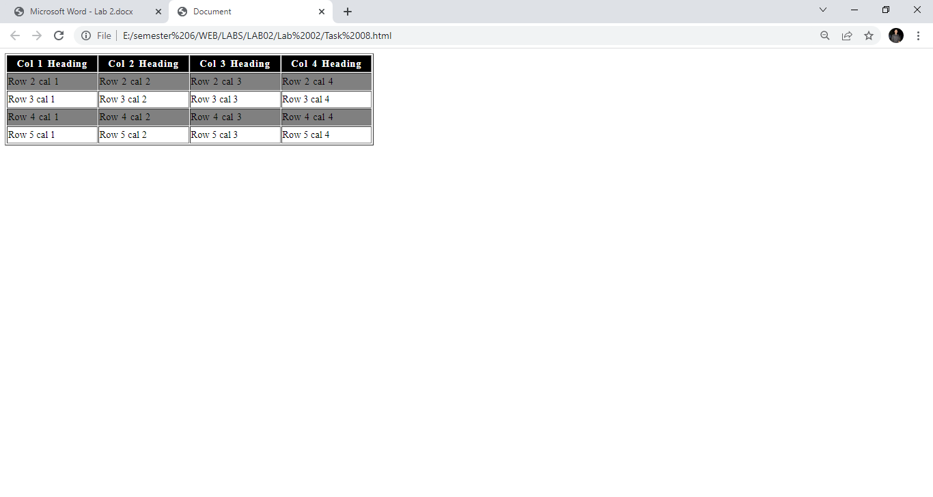

**HTML CODE**

<!DOCTYPE html>

<html lang="en">

<head>

<meta charset="UTF-8">

<meta http-equiv="X-UA-Compatible" content="IE=edge">

<meta name="viewport" content="width=device-width, initial-scale=1.0">

<title>Document</title>

<link rel="stylesheet" href="./8.css">

</head>

<body>

<table border="2px">

<tr class="heading">

<th>Col 1 Heading</th>

<th>Col 2 Heading</th>

<th>Col 3 Heading</th>

<th>Col 4 Heading</th>

</tr>

<tr class="row2">

<td>Row 2 cal 1</td>

<td>Row 2 cal 2</td>

<td>Row 2 cal 3</td>

<td>Row 2 cal 4</td>

</tr>

<tr>

<td>Row 3 cal 1</td>

<td>Row 3 cal 2</td>

<td>Row 3 cal 3</td>

<td>Row 3 cal 4</td>

</tr>

<tr class="row4">

<td>Row 4 cal 1</td>

<td>Row 4 cal 2</td>

<td>Row 4 cal 3</td>

<td>Row 4 cal 4</td>

</tr>

<tr>

<td>Row 5 cal 1</td>

<td>Row 5 cal 2</td>

<td>Row 5 cal 3</td>

<td>Row 5 cal 4</td>

</tr>

</table>

</body>

</html>

**CSS CODE**

.heading {

background-color: black;

color: white;

letter-spacing: 1px;

word-spacing: 2px;

}

.row2 {

background-color: grey;

color: black;

word-spacing: 2px;

}

.row2:hover {

background-color: pink;

}

.row4 {

background-color: grey;

color: black;

word-spacing: 2px;

}

.row4:hover {

background-color: pink;

}

table {

height: 150px;

width: 600px;

}